AWS Task – 1

Login in to AWS.
Search for EC2
Click launch instance

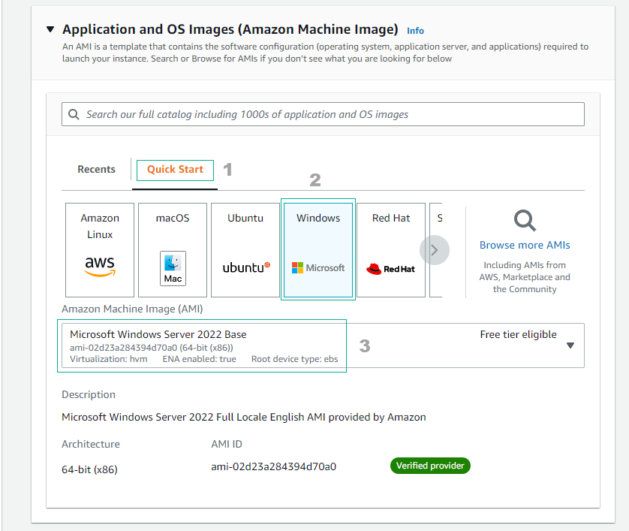

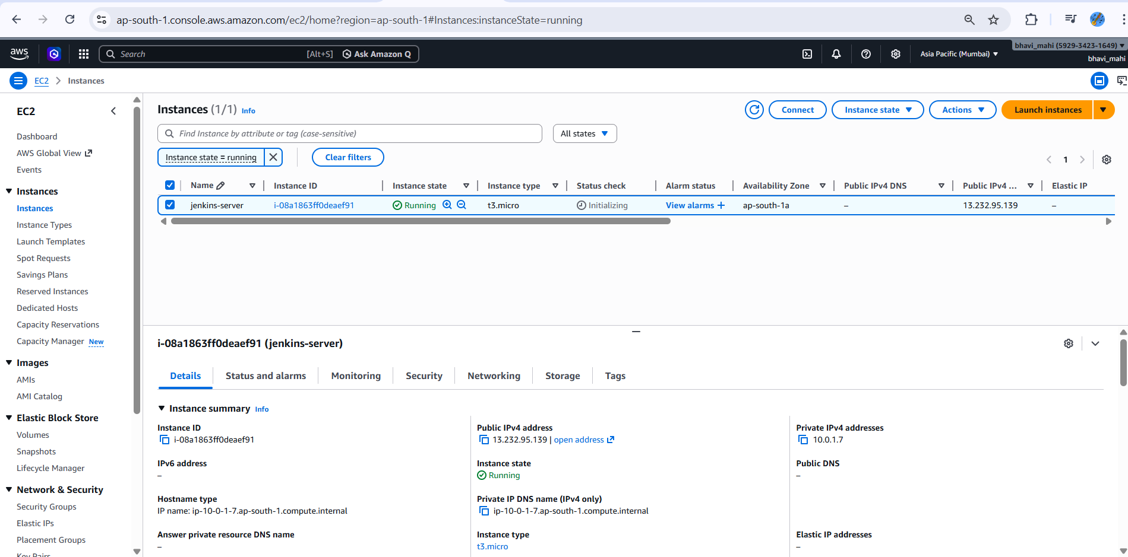

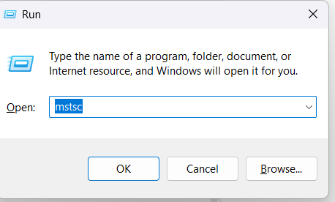

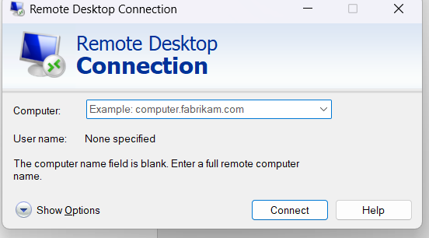

Enter our vpc ip here and connect to the vpc

Commands:

Systeminfo
Ipconfig

